**USE GUIDE**

1. **Client**
   1. **Register**

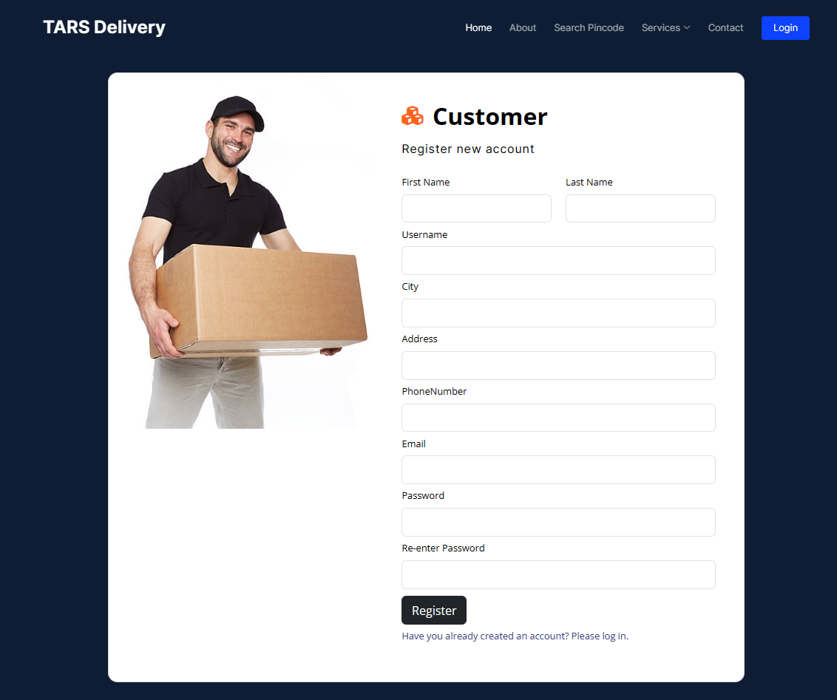Customer must register and then login to make order

**1.2. Login**

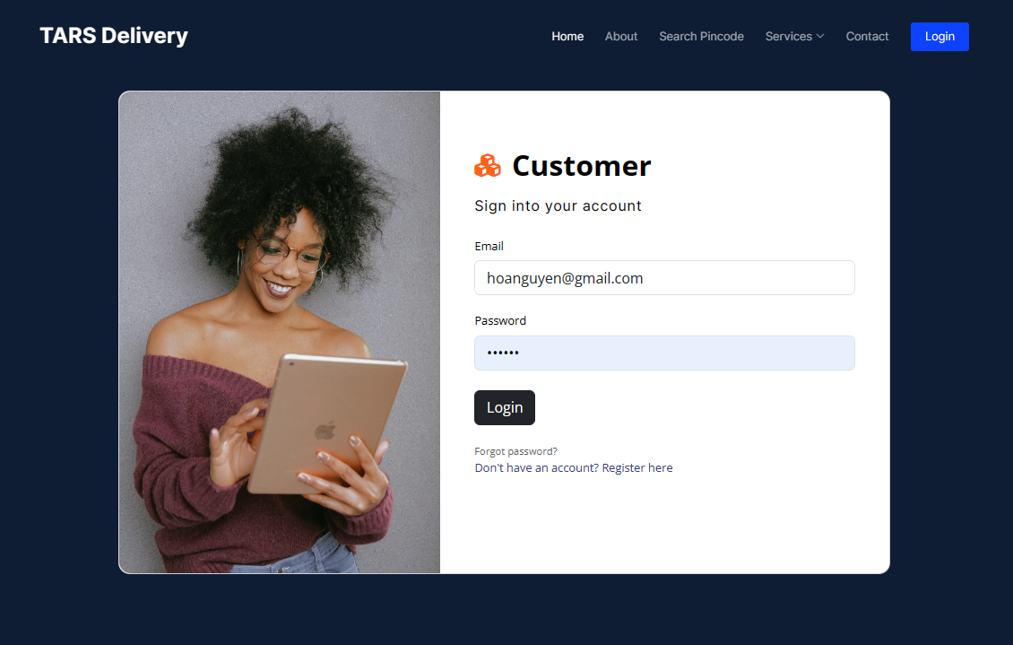

* 1. **Tracking order**

After make order successfully, customer will received an order number to track delivery history of parcel or money transfer

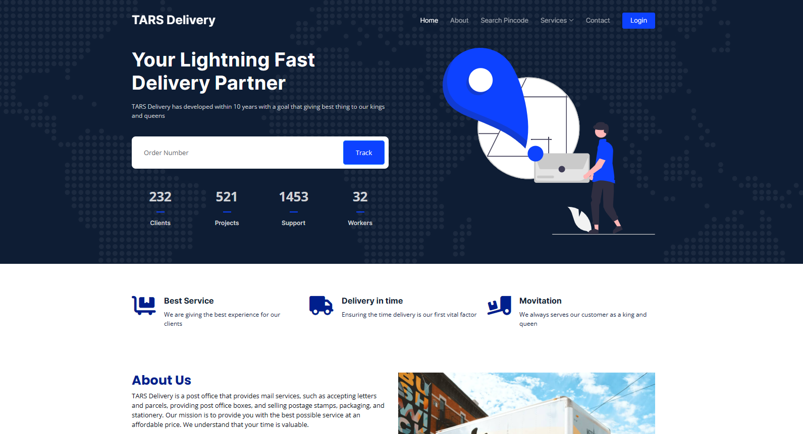

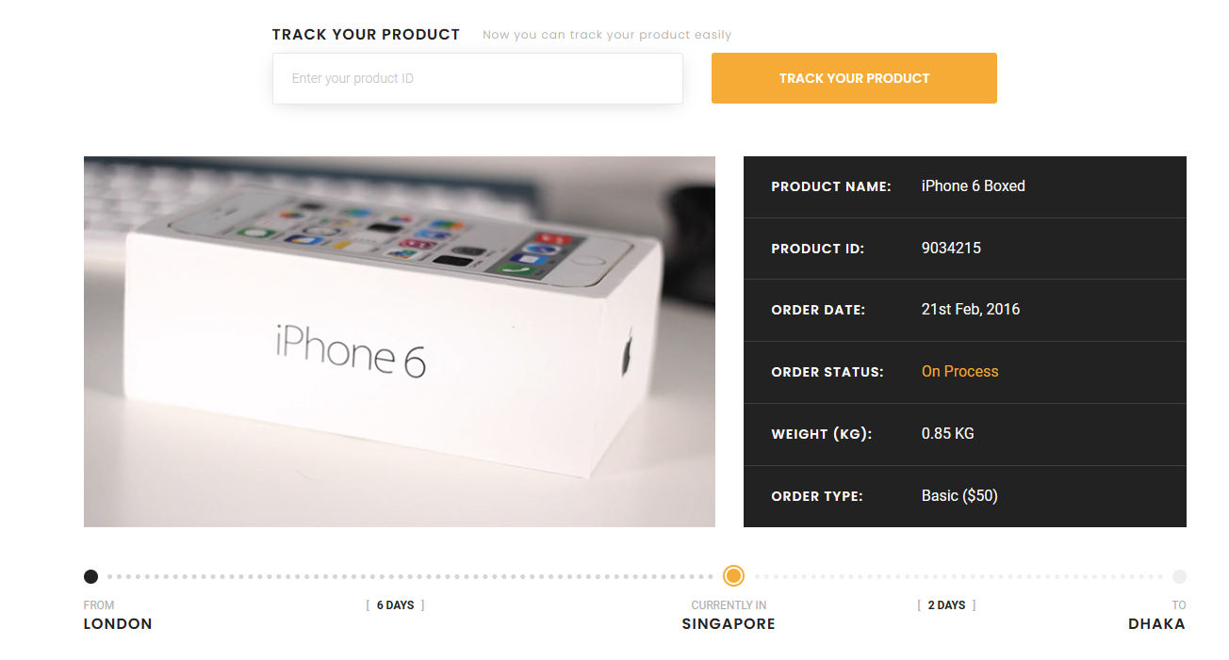

* 1. **Calculate shipping fee**

When input dimensions and weight of parcel, location of receiver and sender, type of parcel and then choose service type, estimated fee will be calculated.

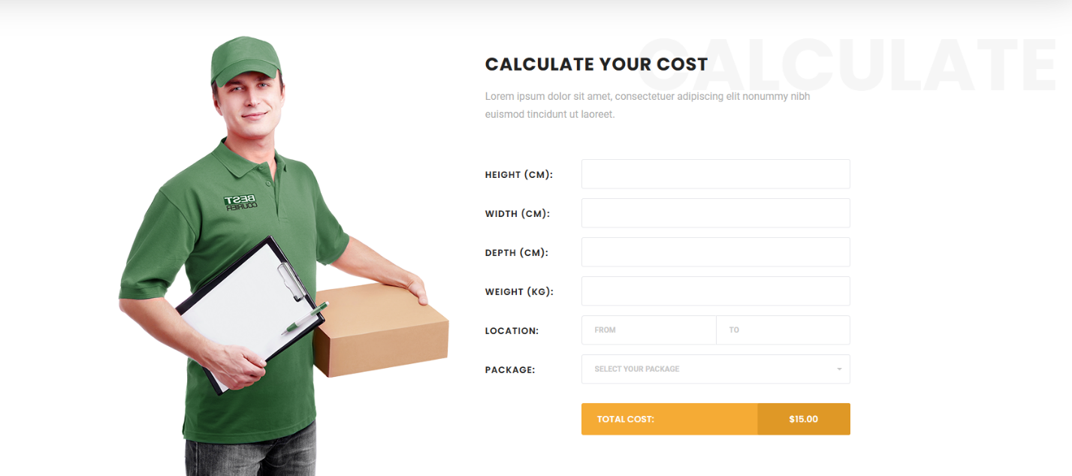

* 1. **Parcel Order Create:**

When you log in successfully, the platform of website will be presented. And this page will help you to create parcel order.

* 1. **Money Order Create:**

Next Page, you can do the money order page if you click on Money Order Section:

* 1. **Money Order Page:**

You can see all money orders page that you have made:

* 1. **Parcel Order Detail Page:**

You can see all parcel orders that you have made, when you click on the field “Shipping ”, it comes to the detail page:

**2.Admin:**

**2.1. login with admin account:**

If you would like to enter the admin page, use the account: [onlinepostofficegroup4@gmail.com](mailto:onlinepostofficegroup4@gmail.com) and the password: “Aptech.123” to log in the system.

**2.2. Create employee page for admin:**

In this page, admin will create some accounts for employee to login the employee to check up and update some fields. The employees are given some functional features for parcel orders:

**2.3. Employee management for admin:**

The admin will manage some employees accounts that they have made:

When clicking on edit, the form will appear:

Or clicking the detail:

**2.4. Money Order Management Page**

The admin will update the status of the order.

**3. Employee**

**3.1. Login:**

If you want to login the employee page to check and update some field of file, click on the link with name: Go to employee login, using the account [**nguyenphuonghoa0709@gmail.com**](mailto:nguyenphuonghoa0709@gmail.com) **and password: “Hoa.12”** or the account which the admin made its own system in order to login the system:

**3.2. Edit profile employee:**

In this page, you can change some of personal information of employee:

**3.3. Change password page:**

You can also change the old password to brand new one that it is more likely to memorize when it comes to login the system:

**3.4 Parcel Order management:**

The employees have a task which manages all of parcel orders and update some field such as vpp value, receive date of order and shipping status:

